Evaporator Control System Design

GF1 Control System: Final Report

Edward England

8th June 2022

Abstract

The forced-circulation evaporator process is non-linear, with high levels of interaction between the variables. The existing control solution for the system consists of three proportional-integral (PI) controllers operating individually to control the separator level, operating pressure, and product composition. These PI controllers were designed around the system’s operating point at a product composition level of 25 %. However, it is expected to that the composition set point will vary between 15 and 35 % during the plant’s operation. Due to the process’ non-linearity and interactivity, the PI controllers are not guaranteed to perform well at these levels. This report sets out to investigate how effective the existing control method is at different composition levels, to investigate alternatives and recommend a solution. Two control methods are investigated: gain scheduling and state feedback. Performance is measured objectively using the integral time absolute error (ITAE) criterion and the duration of time at saturation. Control design is a science of trade-offs, and the investigations identified the strengths and weaknesses of each design. The main findings were that state feedback was more robust to input disturbances as well as variations in process parameters, gain scheduling was marginally more robust to set-point changes and state feedback was better at keeping the system away from saturation. Through considerations of physical implications and the relative trade-offs, it was concluded that a state feedback control system would be the most worthwhile for the improved performance of the system. Although more costly, it showed promising robustness so is very likely to perform well in reality.

1 Introduction

1.1 Evaporator Process

A forced-circulation evaporator mixes feed with a high flowrate of recirculating liquid into a heat exchanger, where the liquor boils and is passed into a separator. There, liquid and vapour are separated, the vapor condensed and discarded, and the liquid recirculated or drawn off [1]. This drawn off liquid is the product: the desirable substance which can be sold, hopefully at a high enough price to make the whole process profitable. As a result, the composition of the product is a key quantity. Consider a crude oil evaporator aiming to produce a product of certain volatility; a substance composed of too many long chain hydrocarbons would give a product which is inadequately volatile, which may be less valuable. It is hence desirable to control the product composition of the evaporator process carefully.

The key subsystems of the evaporator process are detailed in Appendix A, which also explains how a basic computer model of the process was built. Appendix B details how this model is built up to represent a realistic system model, including modelling of servo-controlled valves as first-order lags and signal saturations to prevent quantities from reaching dangerous or unrealistic values.

1.2 Existing System Control

Currently, the system consists of the plant and three SISO control loops. The first is the separator level (L2) control loop using the product flowrate (F2) as the control variable. The separator level is not self-regulatory so a controller must be used for stable operation. A PI controller was designed to give a phase margin of 40 degrees, as detailed in Appendix B.

The second loop controls the operating pressure (P2) using the cooling water flowrate (F200). The operating pressure equation, described in Appendix A, shows it is a self-regulatory process but a controller can be used to change the response of the loop to disturbances and set point changes. Another PI controller is implemented in this loop by again targeting a 40 degree phase margin.

The final control loop controls the product composition (X2) using the steam pressure (P100). A PI controller is used, but this time designed using Ziegler and Nichols recommendations for a one-quarter decay ratio. Note that this gives an oscillatory response, as shown in Figure 1, which is not necessarily desirable in a chemical process as it may cause the substance to become unstable if a state is overshot by a certain amount. For example, if the temperature of propane reaches 260 C (its autoignition temperature) then it will spontaneously combust, with obvious negative consequences.

With all controllers in place, the original L2 loop has a phase margin of 12 degrees, but can be increased to 26 degrees with an increase in gain by 22, as shown in Figure 2.

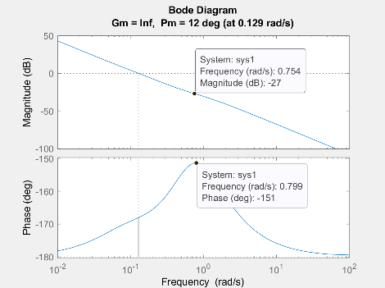

Figure 2: The phase margin of the L2 loop after installation of the other PI controllers is 12



Figure 1: X2 and L2 response to step in L2 set point from 1.0 m to 1.1 m



Figure 1: Oscillatory X2 response to a set point change from 25% to 26%

Evidently the addition of the other controllers had a significant effect on the separator level control, suggesting the process is highly interactive. This is also shown in Figure 3, where a 10% step in the separator level L2 set point causes X2 to react vigorously as well.

Note also, by placing saturation limit on the system variables, the integral control can cause large oscillations if a control variable becomes saturated. A difference exists between the desired value of the control variable and the actual value, and the large error over time builds up a large integrator term which is only removed by a large overshoot in the opposite direction over a period of time. The existing control solution features ‘clamping’ integrator anti-wind up to reduce consequent overshoot.

1.3 Problem Statement

The interactivity between variables makes control of them quite difficult upon changes in set-point. Further, the system is non-linear. This is evident, for example, by applying a small step input to the steam pressure P100 and measuring the steady state gains in the product composition X2. Doubling the size of the step input does not double the change in product composition.

The PI controllers in the three SISO control loops were tuned whilst the system ran at its nominal operating point, namely with a 25% product composition. However, it is important for the plant to be able to operate at a variety of product compositions; it is desired for the composition to be able to vary in the range 15% to 35%. Due to the system’s nonlinearity, the PI controllers tuned around the nominal operating point are not guaranteed, nor likely, to provide equally good performance at different operating points.

Figure 5: X2 response to a 10% disturbance in F1 at different operating points.

Applying a 10% disturbance to the feed flowrate whilst the system is at different operating points exposes the inconsistencies of the PI controller. In this case, a composition of 15% is initially slow to react to the disturbance but is also slow to recover. Product compositions 35% recovers much faster, thought still not as fast as a 25% composition, and also point exhibits very oscillations which is not appealing.

Hence a control method which performs over a wider range of operating points is desirable. It must be robust to changes in system parameters, as the parameters in the model will not necessarily match those in reality. It must feature good disturbance rejection properties, holding the product composition close to the set point. It should keep the process away from saturation limits, which are typically dangerous to run at (e.g. steam pressures should not exceed a certain limit else the pipes may fail). Crucially, it should achieve all of this across the range of operating points.

Alternative solutions for the X2-P2 controller are now investigated, and objective performance measurements are used to compare them to the original PI controller.

2 Investigated Solutions

*2.1 Gain Scheduled Control*

Gain scheduling aims to vary the gain of the PI controller constants depending on the instantaneous operating point of the system. In the case of the evaporator, the PI constant is chosen to depend on the product composition X2.

A simple way to implement gain scheduled control is to pick multiple operating points and to tune a PI(D) controller for each point. If a model does not exist for the system, this is particularly time consuming and even poses a risk to safety; typical PID tuning using the Ziegler-Nichols approach requires bringing the system to the point of instability to find the ‘ultimate gain’ . For an evaporator system, this would not be sensible. Fortunately, we do have a model of the system, thought this method still has downsides. In particular, it is not obvious to know how many PI controllers are required to work around the non-linearity of the system, further adding to the trial-and-error.

A more elegant solution is to aim to maintain a constant overall loop gain , where the loop is around the controller and the process [1].

where is the gain of the controller and is the gain of the process. As the operating point of the non-linear process changes, the value of varies. In order to maintain consistent performance, the controller gain can be scheduled to be the inverse of the non-linear function describing the variation of .

In order to do this, the process gain of the evaporator system was measured for a variety of operating points (which is quicker than tuning PI controllers at each point). The points chosen were X2 =15 : 2.5 : 35.  
With the PI control loop closed, the X2 set point was set to the desired operating point one at a time, and the system was left to stabilise, and the steady state value of P100 then measured. The X2-P100 loop was then broken. The P100 set point was set to the measured steady state value to ensure the value of X2 was steady at the desired operating point, even with the loop open. At the nominal operating point, P100 takes the value of 194.7. A unit step was then applied to P100 which corresponds to a 0.5% disturbance. This % disturbance was applied to all other operating points. It is important for the disturbance to be small such that the system is effectively operating within a linear region about the operating point. The corresponding change in X2 was then measured. The process gain is given by equation 2.

The process gain of the system is shown in Figure 6, and the corresponding controller gain required for constant overall loop gain in Figure 7.



Figure 7: The required controller gain variation to maintain constant .

Figure 6: The process gain varies with the operating point of X2.

The gain schedule was initially implemented in Simulink by splitting the controller gain into three linear regions: [15, 20), [20, 27.5), [27.5, 35]. A linear fit was applied to each region and the equation used to determine the value of . A second implementation used the ‘1D Lookup Table’ block which linearly interpolates between each data point, which is slightly more accurate for little to no extra cost. This also linearly extrapolates outside of the range 15% to 35% should the process leave the region, for example, overshooting from a setpoint change of 32% to 35%.

The value of the proportional gain is hence changed. Since we are using an ideal PI controller, the integral control term is given by so this term is also scaled with the gain schedule (as opposed to a parallel PI form where is independent of ). The performance of the controller is evaluated in Section 3.2.

*2.2 State Feedback Control*

Whilst I focused on the gain-scheduled controller, Abhi and Aki investigated state feedback control.   
The previous control systems have consisted of SISO control loops. These give effective results with a reasonably simple design, but without a complicated multi-variate gain schedule, are unable to account for the high level of interaction between variables. The state feedback controller is a MIMO control system, and hence drives all three control variables given the combination of the states.

The state vector is multiplied by a gain matrix K which described the transfer function from each state to each input. A diagonal K matrix would effectively be three individual proportional gain controllers, and this is how the controller was first implemented. As expected, this system contained errors in steady state. To remove the steady states errors, the integral of the errors are appended to the states vector.

There are two main methods to determining the gain matrix, as described in the following sub-sections.

2.2.1 Pole Placement

Pole placement is the ‘manual’ placing of the controller’s poles. Pole locations are chosen using control theory. In general, the placement of the poles is a trade-off. The larger the gain, the faster the response. However, it also makes the controller much more susceptible to noise and disturbances. Further, large gains are not necessarily feasible since the actuator will eventually reach their upper limit and saturate. For example, if an input is the position of a valve, the valve cannot go open more than its maximum position.

For details of the implementation and design choices of the state feedback system, refer to Akshat and Abhijit’s reports.

2.2.2 Optimal Control

A more refined way to determine the gains matrix is by the use of an optimisation function. It was desired to use the Linear Quadratic Regulator method but unfortunately the team ran into practical issues whilst implementing it in Simulink. See Akshat and Abhijit’s reports for further details.

3 Analysis

*3.1 Performance Metrics*

Determining the performance of a control system is not an exact science. It is desired for the controller to give the best possible performance. However, this has multiple interpretations. It may be that the best controller is the simplest and cheapest one which will do the job safely. In other cases, the best controller is the one which searches for marginal gain in the system response and maximises profits, but will likely be resource intensive to implement.

In this case, the existing PI controller’s performance of the product composition at the nominal operating point is deemed good, and we looked to at least match that performance with the new controllers over the entire operation region.

It is useful to have numerical indices when comparing the performance of the controllers to be more objective in decision making. Following the requirement that the system must feature good disturbance rejection properties, holding the product composition close to the set point, a score based on the integral of the time weighted absolute error (ITAE) is chosen to be used. ITAE is defined in (3)

where is the error between the product composition and its set point. The score we used normalised the error by the set point of the signal such. The reasoning being that we wanted to be able to compare performance of the system at different setpoints. A greater set-point may create greater absolute error, but may have a smaller relative error, hence the new metric was used to analyse the output signals, as defined in equation 4.

Where is the set-point of the output signal.

For analysis of the input variables, it was decided to monitor the rate of change of the input signals. This is an attempt to measure how oscillatory the response might be. Oscillations are not necessarily desired. Significant oscillation may also cause wear and damage on actuators if they must repeatedly move back and forth. The metric for input performance is defined in equation 5.

Further, following the requirement that the system should keep the process away from saturation, a saturation penalty was created – the ‘integral of the time weighted time near saturation’, or ITNS.

Equation 4 defines the penalty, where is a binary value, which takes the value 1 if the signal is within 2.5% of the upper saturation level, or 0, and takes the value 0 if it is operating within a healthy range.

A variety of tests were ran on each system. Firstly, disturbances of 10% and 30% on the feed flowrate, feed composition, feed temperature, cooling water inlet temperature and circulating flowrate was tested whilst the system ran at the nominal product composition of 25%, as well as the extremities: 15% and 35%.

The robustness to system parameters was also tested. The effects of varying the mass of liquid in the evaporator , the rate of heat transfer in the condenser via and the liquid density and area in the separator was investigated for each system at the same product composition values.

Whilst Akhishat determined which tests to run, I created software to automate the Simulink simulations to be run in parallel from MATLAB using an Excel config file whilst Abhijit created software to post-process the data and calculate the ITAE and ITNS values. The results are summarised in the Appendix tables A1 to A6.

*3.2 Evaluation & Comparison*

Tables A1 to A6 in the Appendix are colour coordinated by each test, with a green cell showing the controller with the best performance, and red the worst.

About the nominal operating point, X2 = 25%, it can clearly be seen that the state feedback controller has the best performance. In particular, for many disturbances (T1, T200 and F3), it manages to completely remove the effect on the product composition X2, hence giving an value of 0. For the remainder of the disturbances (F1 and X1), there still remains an effect on the product composition, but it is quickly rejected with many and values less than 5% of the original controller’s. Similar performance is achieved for the disturbance effects on other variables using state feedback.

Comparing the gain scheduled controller and the original PI controller around the nominal operating point (table A2) shows the performance is extremely similar. This initially caused some confusion in the team as to whether the simulations were product the correct results. However, we soon realised this is the correct result; the gain-scheduled controller was specifically designed to match the overall loop gain of the PI controller at the nominal operating point. Hence it is actually a good sign that they are running so similarly here, it shows the gain scheduled controller is performing as designed. As a whole the effects of disturbances on X2 are still reasonably small, with values of the order of 10. The time at saturation generally shows that all signals behave well at this operating point, apart from F200. The gain-scheduled controller in particular shows poor ITNS behaviour, with values up to 5000 versus values around 1 for the standard PI controller. Looking at the timeseries trace of F200 (Figure A1 in the appendix) confirms the signal is saturated for a prolonged period of time.

We now look at the performance of the system at the operating point X2 = 15%, as shown in table A1. Initially, it looks like the state-feedback controller performs the best in general, apart from the disturbance rejection of X2 (which is what we are interested in!). Whilst this may be true, looking at the variation in X2 values across the controllers shows they are actually very similar. For example, for a 10% step increase in X1, the state-feedback controller’s X2 response has an value of 1999. The original PI controller has a value of 1987 and the gain-scheduled controller 1997. Therefore, even though the state-feedback performs the worst, its values are only within 1% and performance can be considered the same. It is true though that the other signals’ disturbance rejection property are enhanced with state-feedback. Interestingly, comparison of the gain-scheduled controller to the original PI controller at this operating point shows the gain-scheduled controller has some benefits. Although the product composition response is *slightly* worse, the response of all other signals is improved.

Finally, disturbance rejection at the operating point of X2 = 35% is analysed. Table A3 shows that it is a close fight between the state-feedback and gain scheduled controller for the disturbance rejections in X2. For disturbances in F1 or T200, the gain-scheduled controller performs best. For other rejections, the state feedback narrowly wins. The gain-scheduled controller is consistently better than the PI controller at this operating point as hoped. This is seen with decreased metrics which indicate less oscillatory behaviour and a quicker response time. This is verified with the time-series trace of the controllers, as seen in Appendix Figure A4.

We now consider the robustness of the controllers to variations in system parameters. System parameters were varied, and the response to a 10% step in F1 recorded. F1 was chosen as the disturbance as the previous tests shows the product composition was sensitive to F1 disturbances. The results are shown in the lower halves of tables A1 to A6. At the nominal operating point, the state-feedback controller clearly shows the best performance. Not only is the absolute performance the best, but also the robustness. The state-feedback controller gives almost the same value for every system parameter variation. The gain-scheduled controller shows worse absolute performance than the standard PI controller as seen previously for this disturbance and operating point. Disappointingly though, its robustness is also worse. For value of of [20, 30, 40] , the PI controller gives X2 values of [17.8, 18.4, 26.6] where as the gain-scheduled controller gives values of [19.3, 22.1, 34.4] which shows more variance.

For the operating point X2=15%, all controller shows similar levels of variance in the values, suggesting similar levels of robustness. The gain-scheduled controller also shows better performance than the original PI controller for all system parameter combinations. For the operating point X2=35, the gain-scheduled controller and state-feedback controller both show very good level of robustness, with consistent values across the board.

*3.3 Considerations*

The state feedback controller is significantly more complex than the PI or gain scheduling controller. As a results, implementation into the system may require many more resources and a have a higher cost.

Given the system already contains PI controllers, gain scheduling would be very simple to implement, requiring only some look up tables to be added to change the controller gain.

It may be worth considering that LQR was not able to be implemented to the state-feedback controller due to practical difficulties and time constraints. If a state-feedback system was installed, LQR control would then always be a possibility in the future. Having said that, the gains of the pole placement state-feedback are so large over the PI controller than and extra gains from LQR would be secondary.

Finally, the actual requirements of the system should be considered. Whilst objective performance and robustness have been considered here, perhaps extreme performance is not needed. If the performance of the existing PI controller at the nominal operating point is sufficient, and if the performance of the gain scheduled controller met this across the operating region, it may have been sufficient. However, comparing figures A2, A3 and A4 do not suggest the gain-scheduling has managed this.

It is worth noting that the gain-scheduled controller was built around the existing PI controller. This is because performance at the nominal operating point was deemed acceptable and it was desired to have this performance across a wider operating region. However, even the existing PI controller did show very oscillatory behaviour, which will not have helped the gain-scheduled controller. A future investigation may be looking into if a different set of PI gains would improve system performance. For example, a quick delve into the problem found that halving the value of in the controller gave a much more controller system response, as shown in Figure 8.

Figure 8:  
Left: X2 response to a set point change from 25% to 35% with the standard PI controller  
Right: X2 response to the same set point change, with the PI gains halved.

In a similar light, a further investigation could be carried out to probe the effects of having a separate gain schedule for the proportional control and the integral control, which could possibly help reduce the oscillations seen at higher product compositions. A simple way of doing this would be to heuristically tune 3 PI controllers at 15%, 25% and 35% product composition for similar oscillatory performance and to interpolate between them. Assuming the system’s responses may be modelled a first order plus dead time, a better way to tune the PI controller may be to select the gains to minimise the ITAE, as detailed in [2].

*3.2 Recommendation*

As a whole, the state-feedback system is shows the most promising performance gains. The very low ITAE values show the controller holds the product composition close to the set-point well when subject to disturbances. Further, the it had very consistent ITAE value under system parameter variation showing the control is robust. This is arguably one of the most important points; our computer models are almost certainly not perfect representations of the real system. However, this robustness to variation in the system shows that even if the model is not a good match, good results are still highly likely. Furthermore, the ITNS values were the smallest for this controller. This shows that state-feedback will also be the safest approach, as it ensures the system is unlikely to run in dangerous operating regions. Finally, the state feedback system generally had the smallest metrics, suggesting the response was also the least oscillatory. In a chemical system such as the evaporator, this is critical as it means the system will not overshoot system limits.

4 Conclusion

The existing PI controller was found to have poor performance outside of the typical operating region of 25% product composition. As a result, it was deemed necessary to investigate alternative control solutions for better operation at a wider range of product compositions. Gain scheduling was investigated. As opposed to manually tuning multiple controllers, the process gain variation with X2 was measured, and the controller gain set to be the inverse of this in order to maintain constant overall loop gain. State feedback control was also modelled, with the gain matrix K determined via pole placement. Unfortunately, LQR control was not able to be implemented. The performance of each of the controllers was investigated. Disturbance rejection tests, set-point changes and system parameter variations were all studied. Results were aimed to be as objective as possible using performance metrics based off ITAE. State feedback control was found to have the smallest ITAE metrics for almost all signal disturbances. It also had the smallest values, showing it was the least oscillatory of the controllers. Gain-scheduling showed a slightly better performance over the standard PI controller, especially at higher product compositions. However, the performance of the standard PI controller at the nominal operating point was not met outside of this region. As a result, the state feedback controller is strongly recommended to be installed in the evaporator system. Its impressive disturbance rejection properties mean it hold the product composition closely to the set point. Its responses to set point changes and disturbances are controlled and not oscillatory and spend very little time at saturation, both of which imply the evaporator will run safely. Most importantly, its robustness under system parameter variation indicates it is highly likely to perform as predicted in the real system.

References

[1] R. B. Newell & P. L. Lee, *Applied Process Control - A Case Study*. Prentice-Hall, 1989.

[2] van der Zalm, G. M. (2004). Tuning of PID-type controllers: literature overview. (DCT rapporten; Vol. 2004.054). Technische Universiteit Eindhoven

Appendix

Table A1: ITAE values for disturbances and system parameter variations with X2 = 15%

Table A2: ITAE values for disturbances and system parameter variations with X2 = 25%

Table A3: ITAE values for disturbances and system parameter variations with X2 = 35%

Table A4: ITNS values for disturbances and system parameter variations with X2 = 15%

Table A5: ITNS values for disturbances and system parameter variations with X2 = 25%

Table A6: ITNS values for disturbances and system parameter variations with X2 = 35%

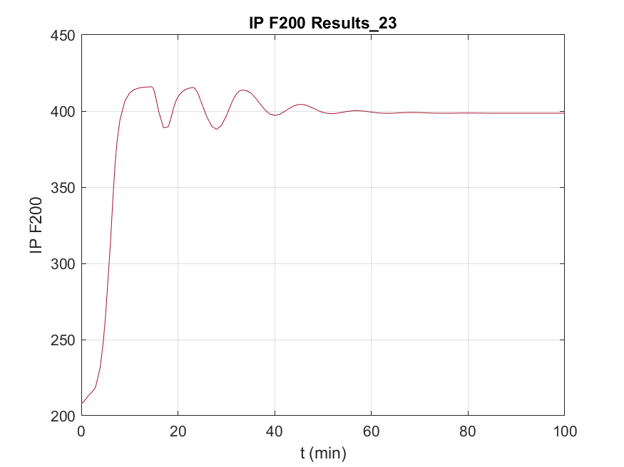.

Figure A1: The F200 response to a 30% step in F1 with the gain-scheduled controller, at the nominal operating point showing significant saturation.

(a)

(b)

(c)

Figure A2: The X2 response to a 10% step in F1 for (a) PI control (b) Gain-Scheduling   
(c) State-Feedback   
for the operating point X2 = 25%

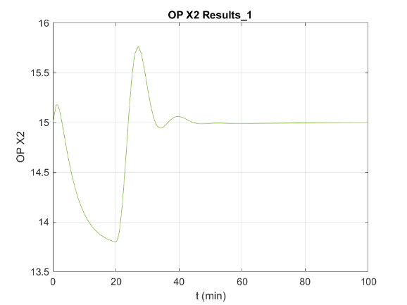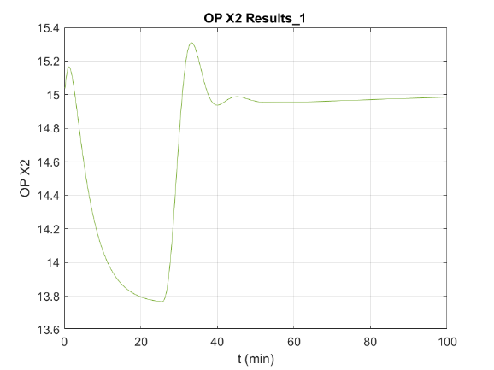

(a)

(b)

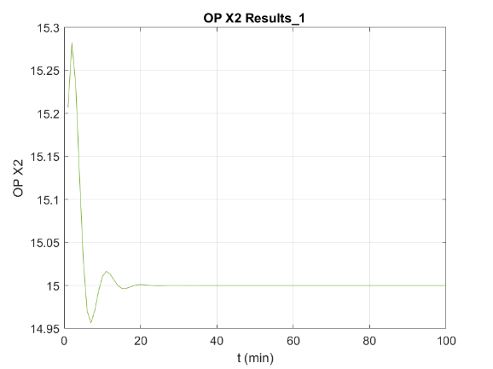

(c)

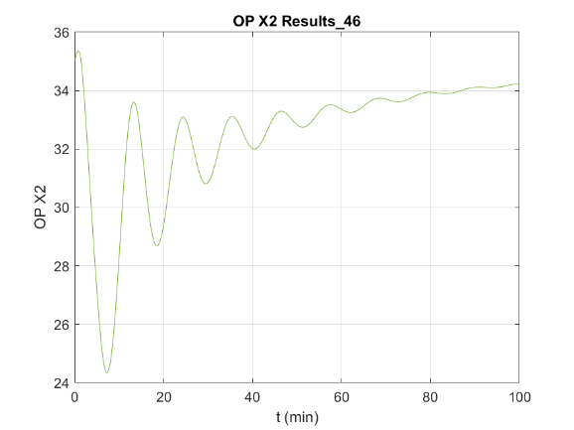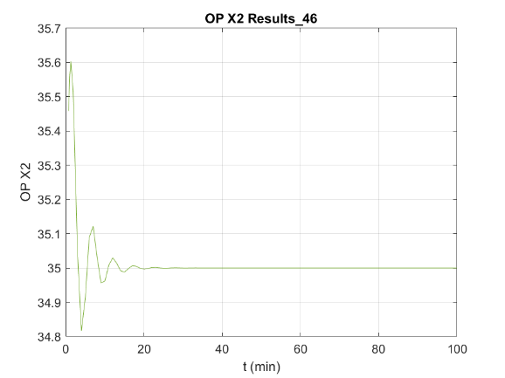Figure A3: The X2 response to a 10% step in F1 for (a) PI control (b) Gain-Scheduling   
(c) State-Feedback   
for the operating point X2 = 15%

(a)

(b)

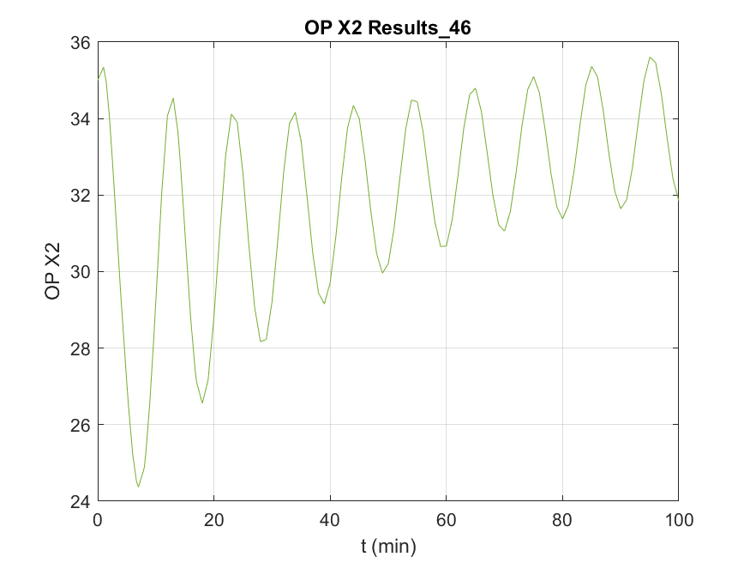

(c)

Figure A4: The X2 response to a 10% step in F1 for (a) PI control (b) Gain-Scheduling   
(c) State-Feedback   
for the operating point X2 = 35%